**Year 10 – Term 2 – Civics and Citizenship (HASS) 2023**

NAME: __________________________ Target: _____ / 37

**Task 2: High Court, international agreements, government policy and laws – Case Study**

**Assessment 2: Assessment 2: Case Study -** Students research and compile relevant information (case study template) about an international agreement Australia has ratified and examples of how it shapes government policies and laws. *(e.g.* ***the protection of World Heritage areas,*** *The Declaration on the Rights of Indigenous Peoples, the Convention on the Rights of the Child or the International Convention on the Elimination of All Forms of Racial Discrimination).*

***PART 2A: Template (5%)***

***PART 2B: Validation (In-class) (5%)***

***PART 2A: Template (5%) Total = 27 marks***

You must complete all sections of the A3 template, using depth and detail. ***You will not be allowed to use the template during the in-class validation.***

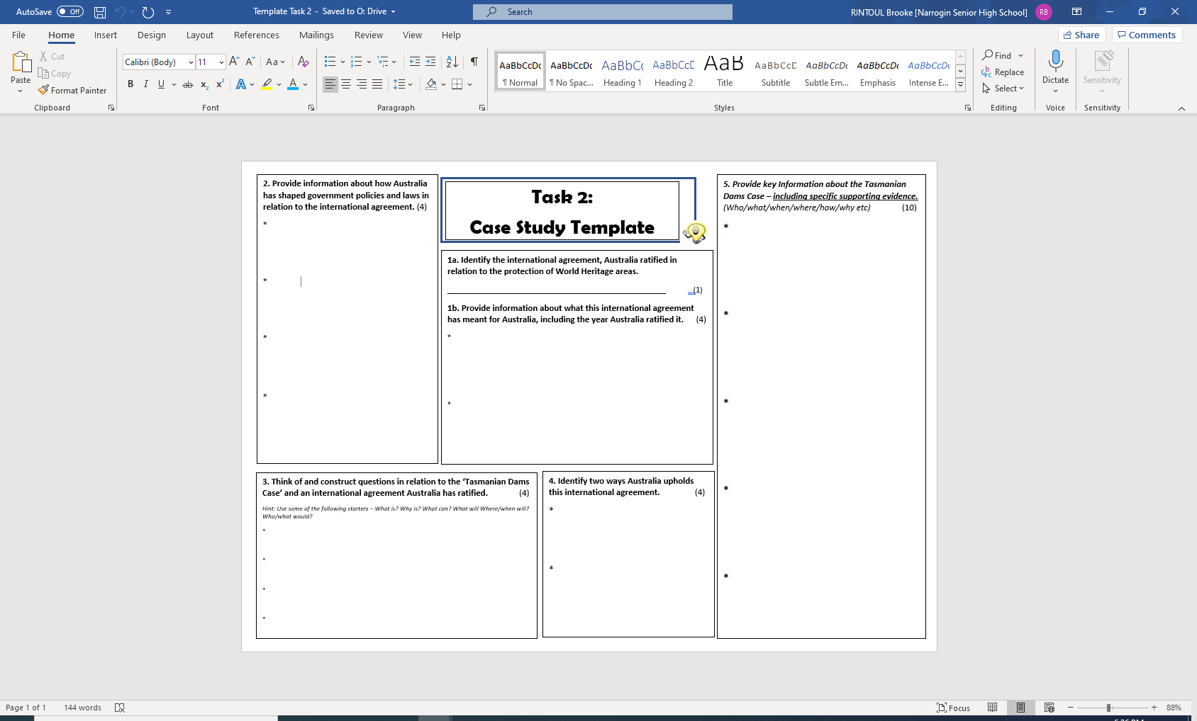**Conditions:** *2 lessons in class (1 lesson on computers and 1 lesson in class using books and resources). You can work on this at home also.*

***PART 2B: Validation (In-class) (5%)* (NO notes allowed)**

***Date: In-class (Week 7, Wednesday 7 June 2023)***

***Conditions: Test Conditions*** ***- 5 minutes planning & 45 minutes working time***

Write a response a minimum 400-word response to the following…

***Total = 10 marks***

***Question:***

***To what extent does Australia uphold ‘the World Heritage Convention’.***

***Hint: Extent -*** the particular degree to which something is or is believed to be the case.

**Particular points to include and address:**

* Background information about the World Heritage Convention, including Australia’s involvement (include supporting evidence, such as examples)
* Supporting evidence – Examples of acts of Parliament (previous and current) Australia has in relation to the World Heritage Convention.
* Supporting evidence – an example of a particular case which has taken place in Australia in relation to the topic. Clearly identifies a case.

*Note: You are encouraged to plan your response before writing your response.*

***PLANNING PAGE: This will not be assessed. You will be given this sheet again in class during the validation.*** Jot down the key points

***Paragraph 1: INTRODUCTION***

***Paragraph 2:***

***Paragraph 3:***

***Paragraph 4: CONCLUSION***